http://www.srpa.co.uk/wp-content/uploads/Web-Logo.jpg

Parent Guide to Online Safety

The Internet is an amazing place….

It allows children to

* Connect with friends
* Make new friends
* Search for new information
* Create, share, view or like images
* Stream live videos through social media apps
* Communicate via voice and video chat
* Play games with people around the world through apps such as Twitch and YouTube

Vs

The Internet is a scary place….

It allows children to

* Connect with friends- *allows bullying to happen*
* Make new friends- *anyone of any age*
* Search for new information- *not always age appropriate*
* Create, share, view or like images- *images may not always be appropriate*
* *Allows for communication with strangers, as well as the sharing of personal data   
   such as location.*

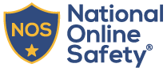Sir Robert Pattinson Academy is a member of the National Online Safety and is working towards centre accreditation.

We are delighted to have parental resources and training available to support parents in keeping their children safe online. A letter is available this evening giving details of how parents can complete the free online training to best prepare them to support and protect their child in the online world. More details can be found at [**https://nationalonlinesafety.com/about-us/**](https://nationalonlinesafety.com/about-us/)**.**

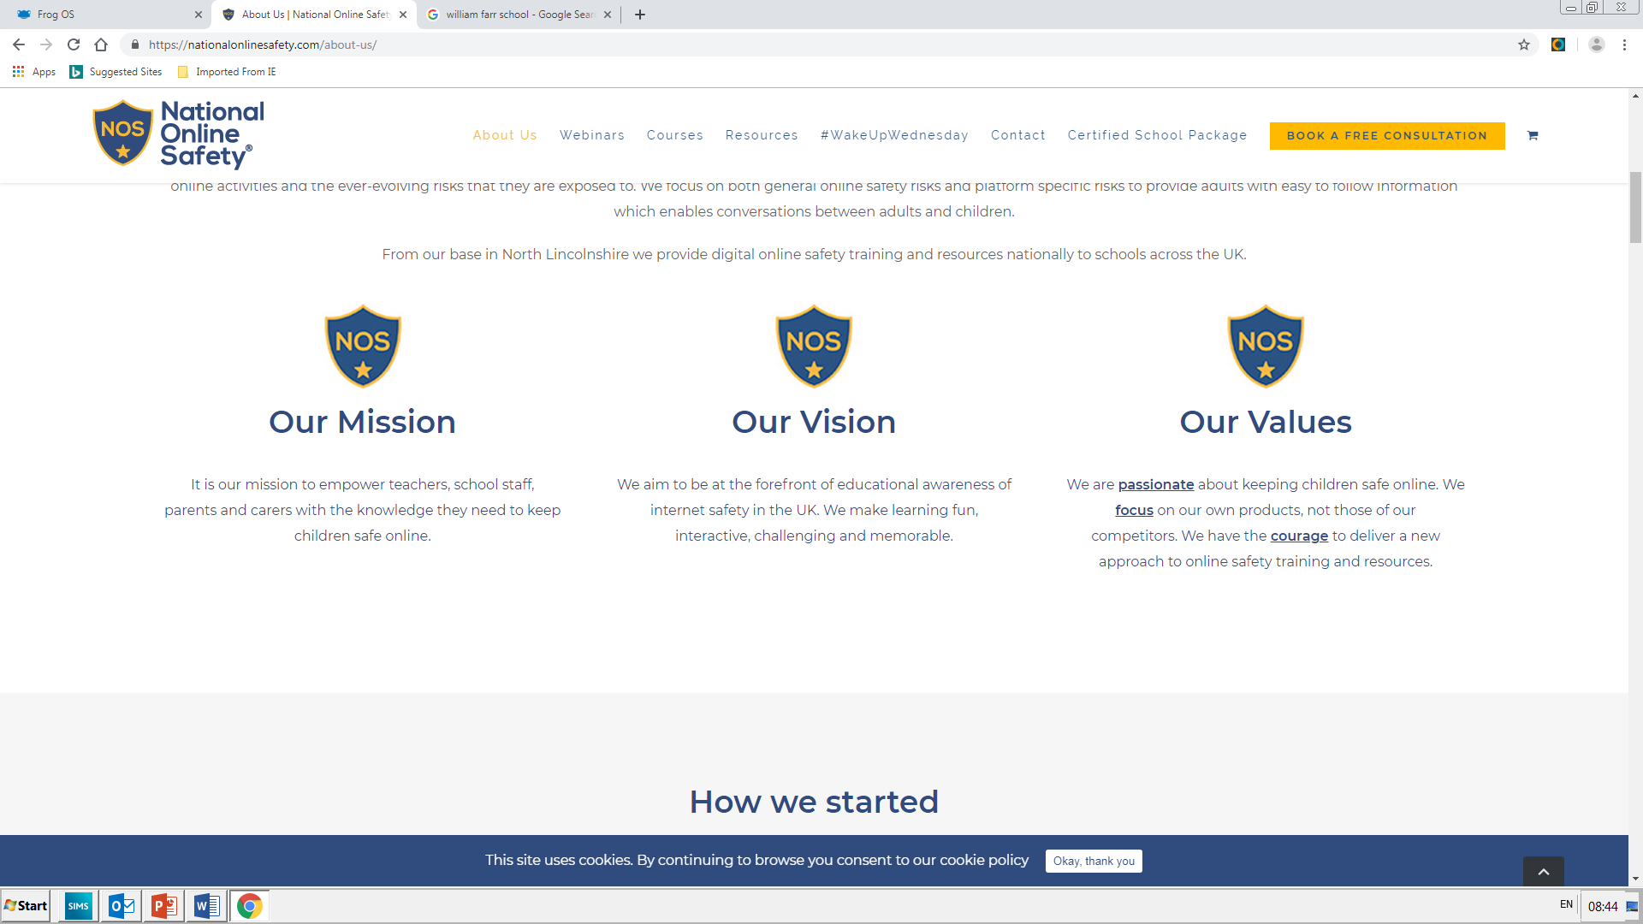

Via our website [**https://www.srpa.co.uk/for-parents/safeguarding/**](https://www.srpa.co.uk/for-parents/safeguarding/) we have an online security section containing valuable guides to all the commonly used Apps and online platforms.

Should you have any concerns or queries, please do not hesitate to contact the Academy:

[Enquiries@srpa.co.uk](mailto:Enquiries@srpa.co.uk)

[antibullying@srpa.co.uk](mailto:antibullying@srpa.co.uk)